**Submitted by : Priyanka.K [2448347]**

**Lab 2 23.06.2025**

1. **Aim and Objective**

**Aim:**

To implement a basic **area monitoring system** using a **PIR motion sensor**, an **LED**, and **Arduino UNO**, which detects movement and alerts by turning ON the LED.

**Objectives:**

• Understand the use of PIR motion sensors in Arduino-based systems.

• Read digital input from the sensor and process it with Arduino.

• Provide visual alerts through external LEDs.

1. **Problem Statement**

Creating a system that detects human motion using a **PIR sensor**. When motion is detected in the sensor’s range, an LED glows

**3. Code**

int a = 0;

void setup()

{

pinMode(2,INPUT);

pinMode(LED_BUILTIN,OUTPUT); //directly reads the from output thats is pin 13 or we should specify

Serial.begin(9600); //data transmit speed (baud rate - millisec)

}

void loop() //runs until we stop

{

a = digitalRead(2); //read the signal through motion sensors - we specifying d pin

if(a == HIGH) {

digitalWrite(LED_BUILTIN,HIGH);

Serial.println("Motion Detected");

} else {

digitalWrite(LED_BUILTIN,LOW);

Serial.println("Motion Not Detected");

}

delay(10);

}

**4. Circuits – System Design**

Connections:

| **Component** | **Arduino Pin** |
| --- | --- |
| PIR VCC | 5V |
| PIR GND | GND |
| PIR OUT | Pin 2 |
| LED | Built-in (Pin 13) |

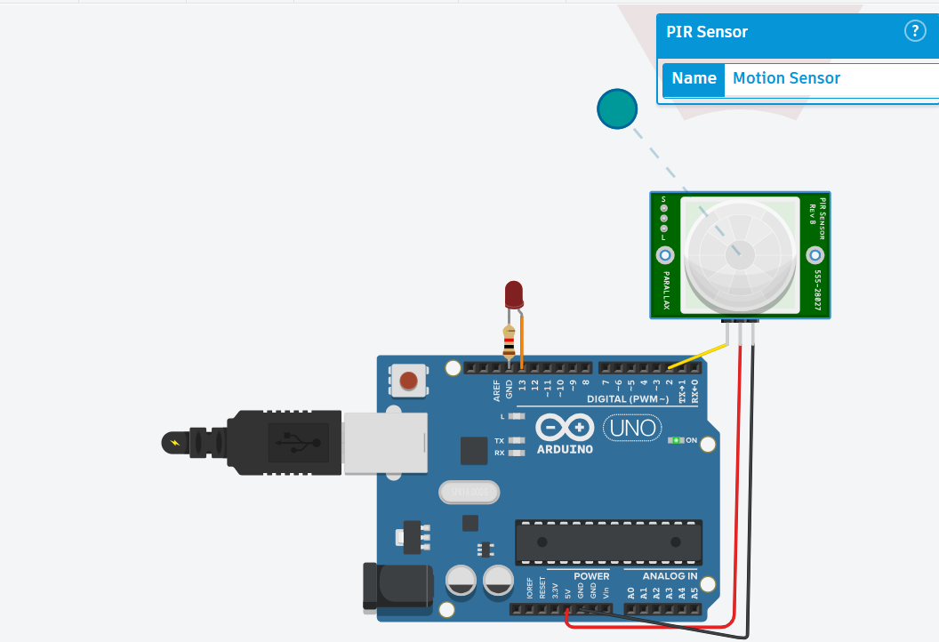

If the motion is not with in the range – LED Bulb will not Glow

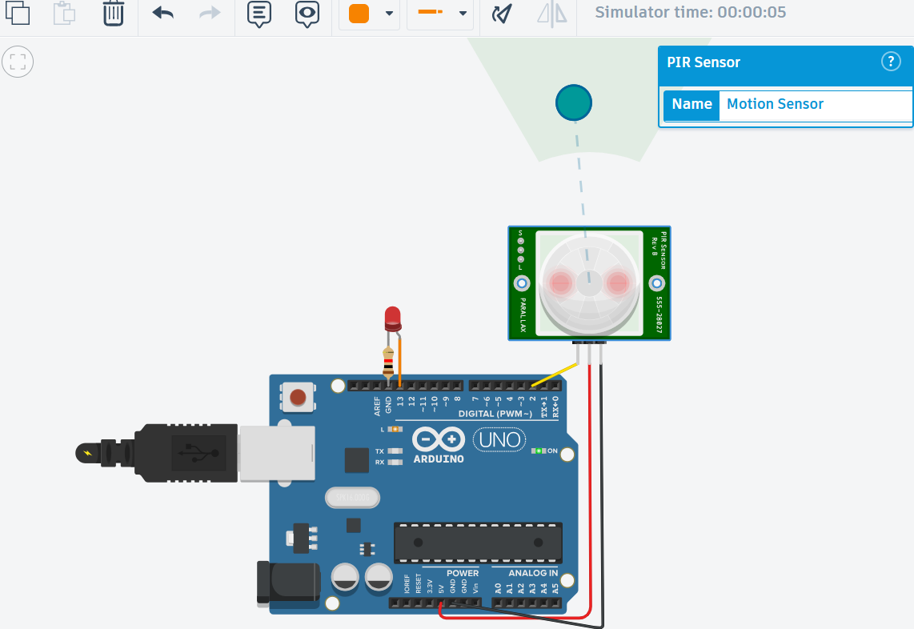

If the motion is with in the range – LED Bulb Glows

**5. Sample Output**

Motion Not Detected

Motion Not Detected

Motion Detected

Motion Detected

Motion Detected

Motion Detected

Motion Not Detected

Motion Not Detected

Motion Not Detected

Motion Not Detected

**6. Challenges**

* Sensor delay after detection (because of internal PIR timing)
* Need for stable power to avoid flickering readings

**7. Application Design**

* **Security Systems:** Detect intruders or movement in restricted zones.
* **Automatic Lighting:** Turn lights ON/OFF when motion is detected.
* **Smart Home Automation:** Integrate with other systems (buzzers, cameras).
* **Energy Saving:** Lights only activate on motion to reduce power usage.

**8. Reflection**

This experiment helped understand how digital sensors like PIR work with Arduino. Real-time motion detection is a simple yet powerful concept in automation and security applications.